Crowhurst Village
Renewable Energy Feasibility Report – Rural Community Energy Fund Stage 1
Energise Sussex Coast
February 2022 | P0027291 Rev00

Issue and Revision Record
Revision | Date | Originator | Checker | Approver | Narrative
0 | 02/02/2022 | MICBE / SUHBA / AMA91 |  |  | Draft for Client review

Disclaimer
This document has been prepared for the titled project or named part thereof and should not be relied upon or used for any other project without an independent check being carried out as to its suitability and prior written authority of RINA Tech UK being obtained. RINA Tech UK accepts no responsibility or liability for the consequence of this document being used for a purpose other than those for which it was commissioned. Any person using or relying on the document for such other purpose will by such use or reliance be taken to confirm his agreement to indemnify RINA Tech UK for all loss or damage resulting therefrom. RINA Tech UK accepts no responsibility or liability for this document to any party other than the person by whom it was commissioned.
As provided for in RINA Tech UK’s proposal, to the extent that this report is based on information supplied by other parties, RINA Tech UK accepts no liability for any loss or damage suffered by the client, whether contractual or tortious, stemming from any conclusions based on data supplied by parties other than RINA Tech UK and used by RINA Tech UK in preparing this report.

Contents
Glossary 4
1 Introduction 5
2 Technical Assessment 6
2.1 Site description 6
2.2 Energy demand and energy efficiency 9
2.2.1 Baseline heat load data 9
2.2.2 Home energy upgrades 10
2.3 Technology 11
2.3.1 Ground source heat pumps 11
2.3.2 Air source heat pumps 20
2.3.3 Roof mounted solar PV 21
2.3.4 Electric vehicle charging 29
2.3.5 Battery storage 29
Appendix A – 30
Appendix B – 31

Glossary
Acronym | Meaning
AC | Alternating Current
ASHP | Air Source Heat Pump
BGS | British Geological Survey
BMS | Building Management System
CAPEX | Capital Expenditure
CFL | Compact Fluorescent Lamp
CO₂ | Carbon Dioxide
CRC | Community Resource Centre
DC | Direct Current
EV | Electric Vehicle
FLEQ | Full Load Equivalent
GSHP | Ground Source Heat Pump
HW | Hot Water
IWI | Internal Wall Insulation
LED | Light Emitting Diode
LTDS | Long Term Development Statement
O&M | Operation & Maintenance
OHL | Overhead Line
PR | Performance Ratio
PV | Photovoltaics
REGO | Renewable Energy Guarantee of Origin
RINA | RINA Tech UK Ltd
SCoP | Seasonal Coefficient of Performance
SSSI | Site of Special Scientific Interest
STHW | Solar Thermal Hot Water
TA | Technical Advisor
TRV | Thermostatic Radiator Valve
WSHP | Water Source Heat Pump
WTG | Wind Turbine Generator

Introduction
RINA Tech UK Limited (‘RINA’) has been appointed by Energise Sussex Coast (‘ESC’ or the ‘Client’) to provide a feasibility study to investigate the potential for low carbon energy systems (the ‘Project’) supplying domestic and non-domestic properties in Crowhurst village, East Sussex. Crowhurst is not connected to the gas network and all properties are heated using a combination of oil or LPG boilers, electric heating, air source heat pumps (‘ASHPs’), and a number with additional solid fuel appliances.
Brighton & Hove Energy Services Co-operative (‘BHESCo’) has provided heat demand assessment of domestic properties with Crowhurst Parish, and including potential energy efficiency improvements, based on an analysis using Carbon Reduction Options for Housing Managers (‘CROHM’) software, and results from individual energy surveys and a community questionnaire.
The feasibility study is funded by the Rural Community Energy Fund (‘RCEF’).
The scope of work undertaken by RINA is based on the proposal ‘RINA_Proposal_Crowhurst RCEF Feasibility Study Rev02’ and includes an assessment of the following:
- Renewable heat provided by ground source heat pumps (‘GSHPs’) and including heat networks.
- Renewable heat provided by air source heat pumps (‘ASHPs’) where connection to a heat network is not viable due to property location and/or restricted access.
- Electrical generation associated with rooftop solar PV (‘PV’).
- Electrical capacity and demand associated with electric vehicle (‘EV’) charging.
- Domestic battery energy storage system (‘BESS’).
RINA visited the site on 14th October and 17th November 2021.
Whilst every effort has been made to check source information, RINA takes no responsibility for the completeness or otherwise of the information provided for the purpose of the study.

Technical Assessment
The following section includes analysis and results from assessments of property heat demand, energy efficiency, renewable energy technologies, EV charging and domestic BESS.
Properties in the village are assessed for suitability of GSHPs connected to closed loop boreholes via low temperature heat networks. In addition, properties are assessed for ASHPs, rooftop PV, EV charging and domestic BESS.

Site description
Crowhurst Parish includes a total of 333 domestic properties of varying age, type, size and construction, the vast majority privately owned, and including a small number of properties owned by Optivo Housing Association. Over 90% of properties are located within Crowhurst village, with the remainder distributed throughout the parish, and relatively isolated. Crowhurst Parish is located within the High Weald Area of Outstanding Natural Beauty (‘AONB’).
The village is laid out into three main areas – area north of the Hastings to London railway line, area south of the railway line up to properties near to St. Georges Church and Manor House ruins, and the area further south up to the recreation ground. Powdermill Stream runs through the southern end of the village. The topography of the village is relatively undulating, with frequent elevation changes.
Outside of individual private homes, the major landowner of farmland within and surrounding the village is the Diment family. Other landowners include Crowhurst Parish Council (recreation ground), Optivo Housing Association, East Sussex County Council (‘ESCC’), Blacklands Farm, and other private landowners with small individual plots of land.
The majority of properties are heated by oil boilers and electric storage heaters, with a small number heated by LPG boilers and ASHPs. Heating systems in a number of properties are supplemented by solid fuel appliances, expected to be woodfuel stoves.
There are a number of non-domestic properties in the village, as follows.
- Crowhurst CofE Primary School.
- Village hall.
- St. Georges Church.
- Crowhurst Chapel.
- Scout hut.
- Cricket pavilion.
- The Plough Inn.
- Christian Healing Centre.
- Edendale Lodge Care Home.
- Crowhurst Care Home.
- Furness garage.
Crowhurst Parish is shown in Figure 1 below.
Figure 1: Crowhurst Parish
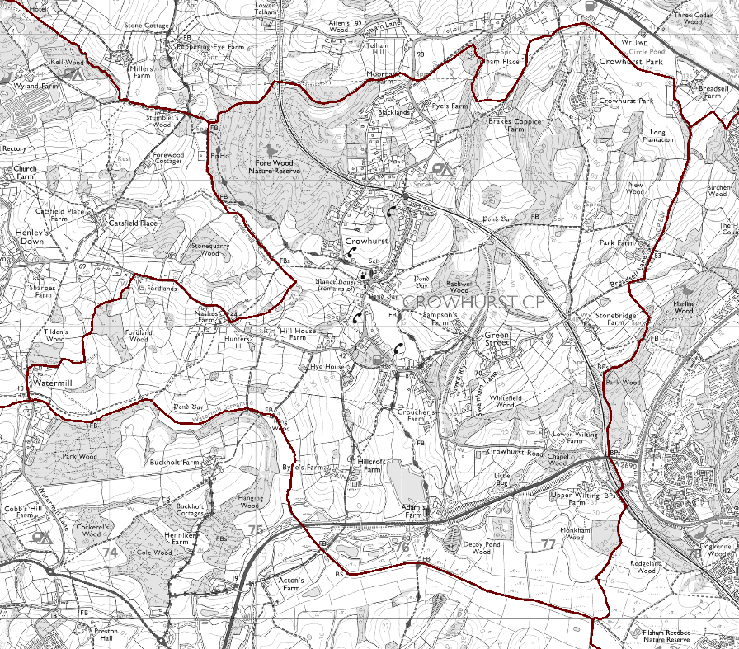
Crowhurst village is shown in Figure 3 below.
Figure 2: Crowhurst village
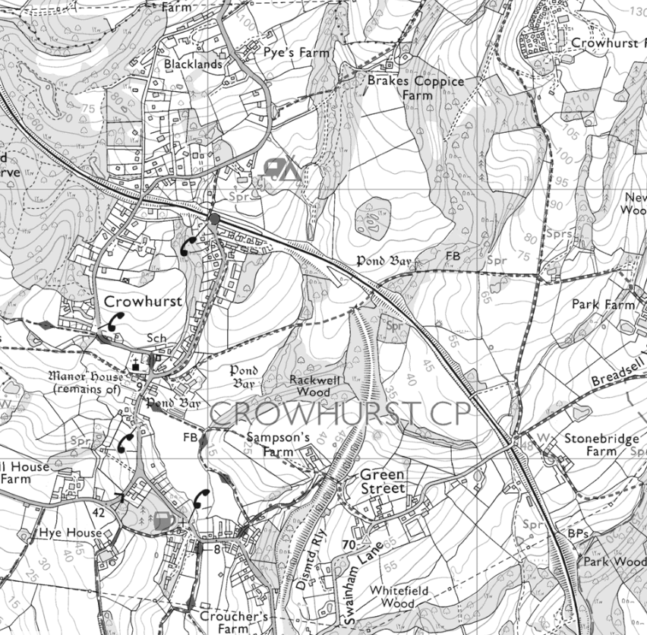

Crowhurst village showing northern, central and southern areas is shown in Figure 3 below.
Figure 3: Crowhurst village showing northern, central and southern areas
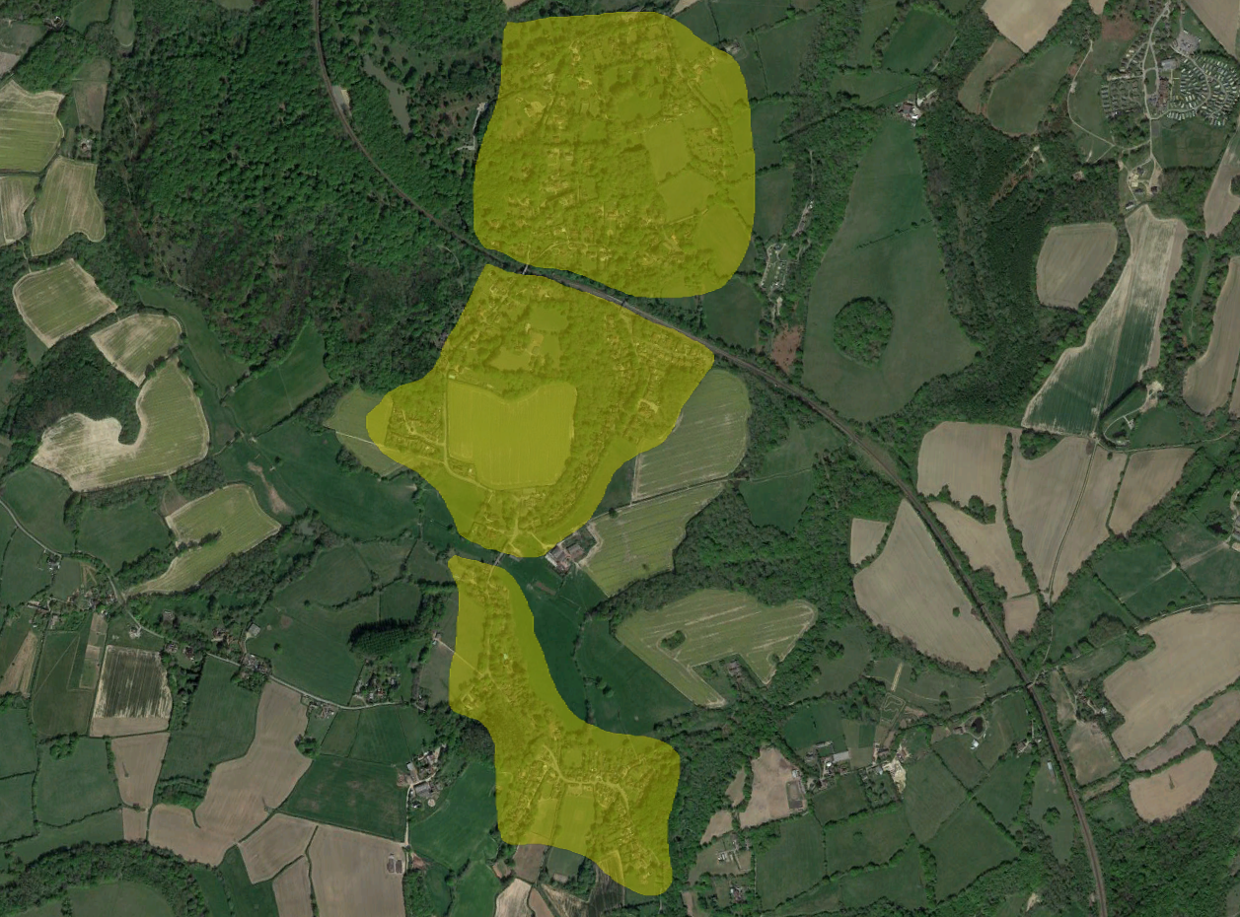

Energy demand and energy efficiency

Baseline heat load data
BHESCo commissioned a database of the village properties from Parity Projects who used their sophisticated suite of analysis tools to build a database of the parameters affecting energy performance for each individual house in the village, we will refer to this database as the CROHM tool. The foundation of the database is publicly available data from Energy Performance Certificates (‘EPCs’) supplemented with other information to improve the accuracy. In the case of Crowhurst, both detailed surveys within homes and externally have been used to refine the database. The baseline total heating demand for the village is shown in Table 1 below.
Table 1: Baseline total heating demand
Parameter | Baseline figures
Total number of homes | 333
Total village heating energy demand (kWh/yr) | 5,434,335
Average home heating energy demand (kWh/yr) | 16,270

Home energy upgrades
The real advantage of the CROHM database is that the impact of energy saving measures can be quantified by applying it to homes within the tool. We used the outcomes from the village questionnaire to assess the number of homes which would be likely to undertake various energy saving measures. This ‘fabric first’ approach is recommended partly to ensure that heating systems are correctly sized for each home, but primarily to reduce energy consumption and operating costs.
The questionnaire results showed that homeowners were most likely to install loft insulation or cavity wall insulation, if their homes were suitable. Most homes already had double glazing and some of those with single glazing are unable to install double glazing due to their home’s listed status. A small proportion of homeowners would install floor insulation. Only one or two homeowners were willing to install more complex measures such as internal or external wall insulation and due to this low uptake we did not model application of these measures to any homes in the village. A summary of questionnaire results is shown in Table 2 below.
Table 2: Questionnaire results summary
Energy saving measure | Notes | Number of homes | Proportion of properties
Loft insulation increase to 300 mm | Most popular measure, 70% of questionnaire respondents stated they would do this. | 235 | 70%
Cavity wall insulation | Only applied to homes built from 1930. | 99 | 30%
Double glazing | Only applied to homes which currently have single glazing (total 44). | 11 | 25% of those with single glazing
Floor insulation | Applied to proportion of homes with suspended floor. | 33 | 10%
The impact of these measures on the total energy consumption can be seen in Table 3 below. The average saving across the whole village is 6% (960 kWh per home) with a small number of homes achieving greater than 40% reduction in heating consumption where they currently have no loft, cavity wall or floor insulation.
Table 3: Impact of energy saving measures on heat demand
Parameter | Baseline | Following energy saving measures
Total number of homes | 333
Total village heating energy demand (kWh/yr) | 5,434,335 | 5,114,282
Average home heating energy demand (kWh/yr) | 16,270 | 15,312

Technology

Ground source heat pumps
The following section provides an assessment of ground source heat pumps (‘GSHPs) and closed loop vertical borehole heat collectors, combined with heat networks to supply each property.
Ground source heat pumps operating as part of a closed loop system extract low temperature heat from the ground via a mix of water (75%) and glycol (25%) (commonly termed ‘brine’), circulated via a pump through buried pipework, with the pipework acting as a heat exchanger with the ground. Within the heat pump the heat from the water/glycol is transferred to a refrigerant circuit via a heat exchanger where the temperature of the refrigerant is raised via compression using an electrically driven compressor to temperatures suitable for space heating and hot water (‘HW’). The overall efficiency of the process is dependent on the difference in temperature between the heat source (ground) and the heat sink (heat loads), the lower the temperature difference, the higher the efficiency. Closed loop borehole GSHPs operating in the UK delivering heat to a building heating circuit at 50°C will operate with a heat pump seasonal coefficient of performance (‘SCoP’) of around 3.8 (380% efficient).
A shared ground loop (‘SGL’) heat pump system includes individual property GSHPs connected to a borehole array, where the extracted heat is shared between properties via a low temperature heat network (flow and return pipework system) connecting the borehole array to each GSHP.
The analysis which follows is based on GSHPs replacing existing oil boilers, LPG boilers and electric heating.

Heat network analysis
The assessment of GSHPs for domestic properties in the village is based on identifying individual clusters of properties grouped together which feature nearby areas of land potentially suitable for the installation of vertical boreholes, with available routes for buried flow & return pipework connecting from each borehole array to individual groups of properties. The assessment is based on information gathered from site visits, information received from the Client, and aerial mapping.
None of the heat networks include connections to non-domestic buildings, due either to a small heat load, their location being remote from domestic property clusters, or, where connection to a domestic property cluster is possible, a lack of engagement from property managers or owners. It is noted that new oil boilers will shortly be installed at the school in place of the existing oil boilers.
It is noted that there are a small number of additional clusters of properties in the village, however these are not included in the list of heat networks due to insufficient areas of land nearby, lack of access, or lack of available routes for pipework.
It is noted that properties identified as part of heat networks which are currently heated by ASHPs have not been excluded, based on the assumption that ASHPs could be replaced by GSHPs in the future.
A summary of identified heat networks and heat loads is shown in Table 4 below.
Table 4: Summary of heat networks including peak heat loads & demands
Heat network label | Number of properties | Area description & predominant property type | Peak heat load (kW) | Heat demand (MWh/yr)
HN1 | 30 | Forewood Rise.  Terraced houses & flats | 194.0 | 333.6
HN2 | 3 | Court Lodge Cottages.  Terraced houses | 25.0 | 40.6
HN3 | 27 | Craig Close.  Terraced, semi-detached & detached houses & bungalows | 194.6 | 327.2
HN4 | 3 | Forewood Lane south 1.  Detached houses | 60.7 | 86.7
HN5 | 12 | Woodland Way.  Detached houses & bungalows | 117.2 | 185.9
HN6 | 16 | Blacksmiths Field.  Semi-detached houses & bungalows | 83.0 | 147.9
HN7 | 7 | Sandrock Hill north 1.  Terraced, semi-detached & detached houses | 64.2 | 101.5
HN8 | 10 | Sandrock Hill north 2 & Sampson’s Lane.  Semi-detached & detached houses & bungalows | 109.0 | 169.2
HN9 | 6 | Station Road 1.  Detached houses | 76.8 | 116.5
HN10 | 4 | Stonebridge Farm.  Detached houses | 49.6 | 72.3
HN11 | 7 | Sandrock Hill south 1.  Semi-detached & detached houses & bungalows | 89.5 | 134.8
HN12 | 7 | Sandrock Hill south 2.  Semi-detached & detached houses & bungalows | 79.3 | 122.9
HN13 | 10 | Station Road 2.  Detached houses | 114.7 | 177.3
HN14 | 6 | Forewood Lane north 1.  Detached houses & bungalow | 108.5 | 156.7
HN15 | 9 | Forewood Lane north 2.  Detached houses | 147.4 | 215.9
HN16 | 8 | Old Forewood Lane.  Detached houses | 147.7 | 213.2
HN17 | 2 | Forewood Lane south 2.  Detached houses | 41.9 | 59.7
Totals | 166 | - | 1,703.0 | 2,661.9
Further information including electrical loads, ground heat extracted and quantity of boreholes for each heat network is shown in Table 5 below.
Table 5: Summary of heat networks including electrical loads and numbers of boreholes
Heat network label | Number of properties | Peak electrical load (kW) | Electricity demand (MWh/yr) | Heat extracted from ground (kWh/yr) | No. of boreholes
HN1 | 30 | 72.8 | 97.9 | 247.4 | 26
HN2 | 3 | 9.4 | 11.9 | 30.1 | 3
HN3 | 27 | 73.6 | 96.7 | 242.1 | 26
HN4 | 3 | 24.5 | 26.4 | 63.5 | 7
HN5 | 12 | 44.3 | 54.3 | 138.1 | 16
HN6 | 16 | 31.5 | 43.6 | 109.5 | 12
HN7 | 7 | 24.7 | 30.0 | 75.1 | 8
HN8 | 10 | 42.2 | 50.6 | 124.7 | 14
HN9 | 6 | 29.9 | 34.7 | 86.0 | 10
HN10 | 4 | 19.6 | 21.6 | 53.3 | 6
HN11 | 7 | 35.1 | 40.3 | 99.3 | 11
HN12 | 7 | 30.6 | 36.6 | 90.7 | 10
HN13 | 10 | 44.3 | 52.7 | 130.9 | 14
HN14 | 6 | 43.6 | 47.5 | 114.9 | 13
HN15 | 9 | 58.2 | 64.6 | 159.0 | 18
HN16 | 8 | 60.1 | 65.3 | 155.8 | 19
HN17 | 2 | 16.7 | 17.9 | 43.9 | 5
Totals | 166 | 661.1 | 792.6 | 1,964.4 | 218
Figures in Tables 4 and 5 are calculated based on the following:
- Heat demand based on Carbon Reduction Options for Housing Managers (‘CROHM’) analysis, results from individual energy surveys and the community questionnaire, and include potential energy efficiency improvements, assessed on an individual property basis.
- Peak heat loads to be supplied by heat pumps are based on CROHM analysis, results from individual energy surveys and community questionnaire, and including potential energy efficiency improvements, plus a factor of 10%.
- Local bedrock conditions comprise a mix of mudstone, siltstone & sandstone (Wadhurst Clay Formation), based on British Geological Survey data, with an estimated ground thermal conductivity of 2.2 W/mK (based on Microgeneration Certification Scheme (‘MCS’) methodology).
- Year-round ground temperature 10.2°C (depth >15m below ground surface level) (based on MCS methodology).
- Heat pump maximum heat supply temperature 55°C, to supply existing radiator circuits and new hot water (‘HW’) storage tanks. Existing radiators to be replaced with larger units to deliver similar heat output where required.
- Heat pump seasonal coefficient of performance (‘SCoP’) between 3.71 and 3.92 (depending on kW capacity of heat pump), based on example equipment referenced in the MCS product directory.
- Heat pump coefficient of performance (‘CoP’) including electrical capacity of brine pump between 2.49 and 2.68 (depending on kW capacity of heat pump), based on example equipment technical data.
- Heat pump seasonal performance factor (‘SPF’) including electricity demand associated with brine pump between 3.26 to 3.45 (depending on kW capacity of heat pump), based on example equipment technical data.
- Maximum power extracted per metre of heat collector between 37 and 39 W/m, dependant on heat pump annual full load equivalent (‘FLEQ’) hours (based on MCS methodology).
- Number of boreholes based on an approximate borehole depth of 150m.
In addition the following is noted:
- For each borehole array, a maximum of two parallel rows of boreholes, with boreholes in each row 10m apart, and 6m between each row. Where boreholes form a single line, boreholes a minimum of 6m apart.
- Each borehole array includes a buried manifold connecting together individual boreholes, and located on the boundary of each land area to enable access for maintenance.
- Heat network routes are based on ease of access to each property, avoiding roads and other hard dig areas if at all possible.
- Interconnecting pipework between boreholes, and heat network pipework are a minimum of 0.75m below ground level, and therefore not affecting existing agricultural use.
- Larger properties requiring heat pumps with a heat capacity of 16 kW and above will require a 3-phase electricity supply.
- Heat pumps to include new HW storage tanks, either integrated with the heat pump as a single unit where space allows, or as a separate unit.
- Heat pumps and HW tanks to be located inside each property where space allows, otherwise external in a suitable weatherproof enclosure.
- Based on visual inspection of the village, in the case of properties with existing boilers the vast majority are located either at the side or at the rear of the property, and this is reflected in the heat networks’ provisional layout, with the expectation that heat pumps would be located at the existing boiler position, or in the rear garden.
- Stonebridge Farmhouse (part of HN10) is Grade II Listed and may be subject to planning restrictions where a heat pump is installed externally in a new enclosure within the curtilage of the property.
- The local sewage network originating at the eastern end of Craig Close and Forewood Rise, runs south to the Southern Water pumping station located to the north of properties on Sandrock Hill across from the recreation ground, and continuing to Hastings. This potentially interferes with heat pipework as part of heat networks HN1, HN3, HN5, HN6, HN7, HN8, HN11 and HN12, and would require further investigation to confirm suitable pipework routes.
- Areas of land to the east of Powdermill Stream are within a Flood zone 3 area, and it is known locally that low lying farmland to the east of Chapel Hill and north of Sandrock Hill is subject to periodic flooding. Borehole arrays as part of heat networks HN4, HN7, HN8 and HN17 are located in these areas, and this would require further investigation to assess the potential impact from a flood event on equipment maintenance, and mitigation measures.
The locations of each heat network are shown in Figure 4 below.
Figure 4: Heat network locations
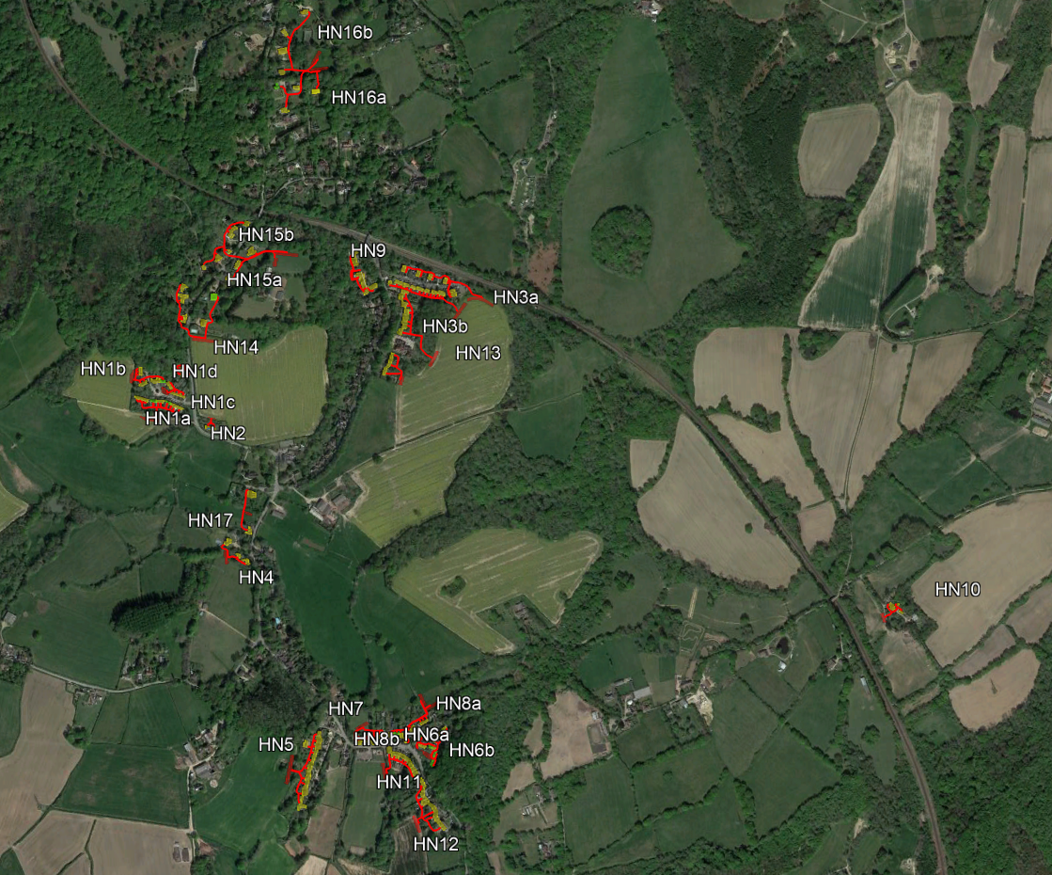
A number of heat networks are split into sub-networks, which include individual borehole arrays serving specific groups of properties.
Properties highlighted in yellow identify those with existing boilers or electric heating, green highlighted properties identify those with existing ASHPs, red highlighted areas denote borehole arrays, and red lines show heat network routes.
The locations of individual groups of heat networks and sub-networks (denoted a, b etc) are shown in Tables 5 to 8 below.
Figure 5: Heat network locations - north
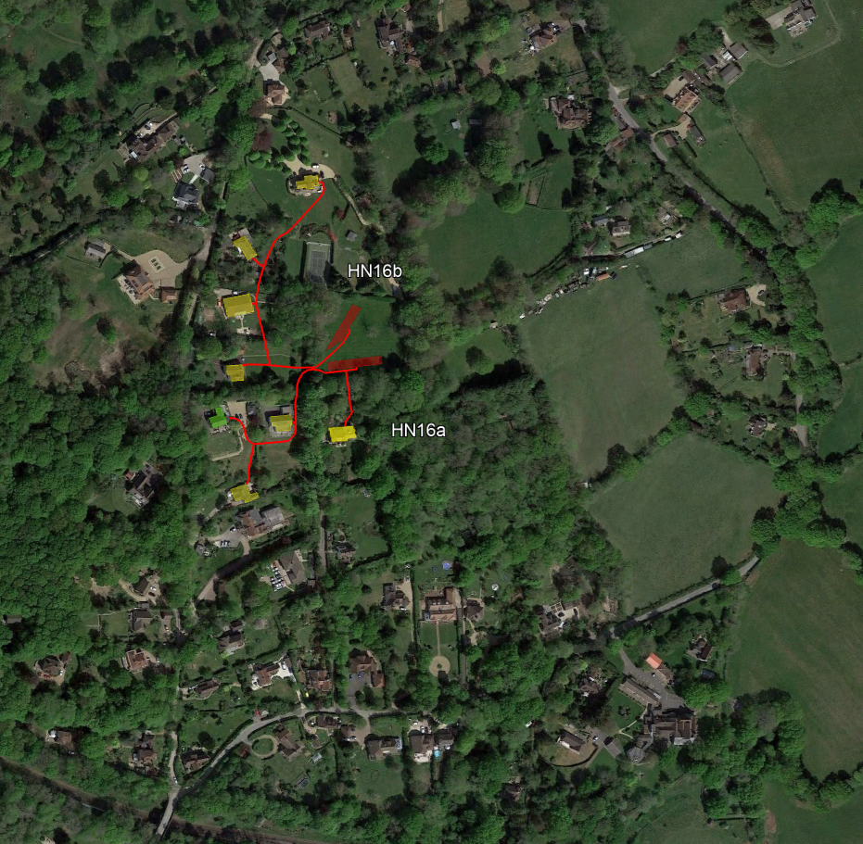
Figure 6: Heat network locations – central
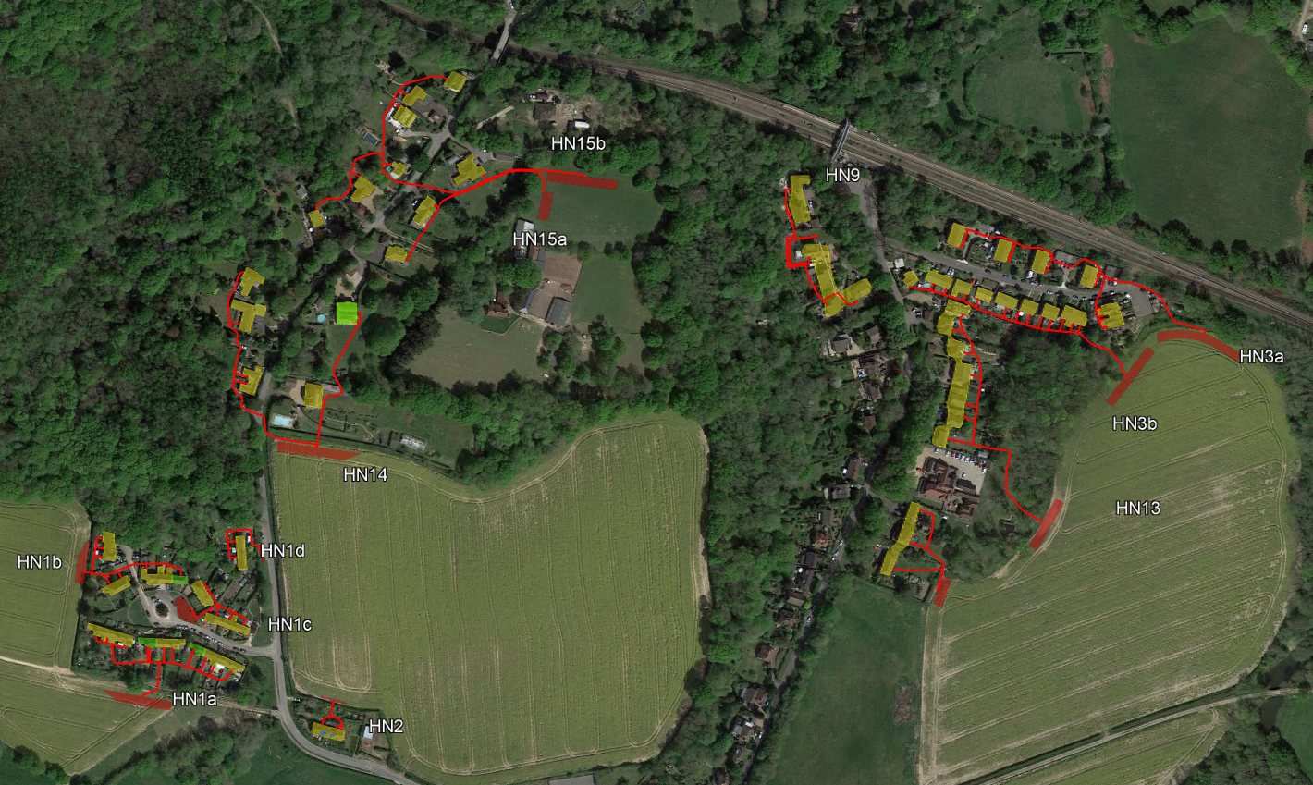
Figure 7: Heat network locations – south
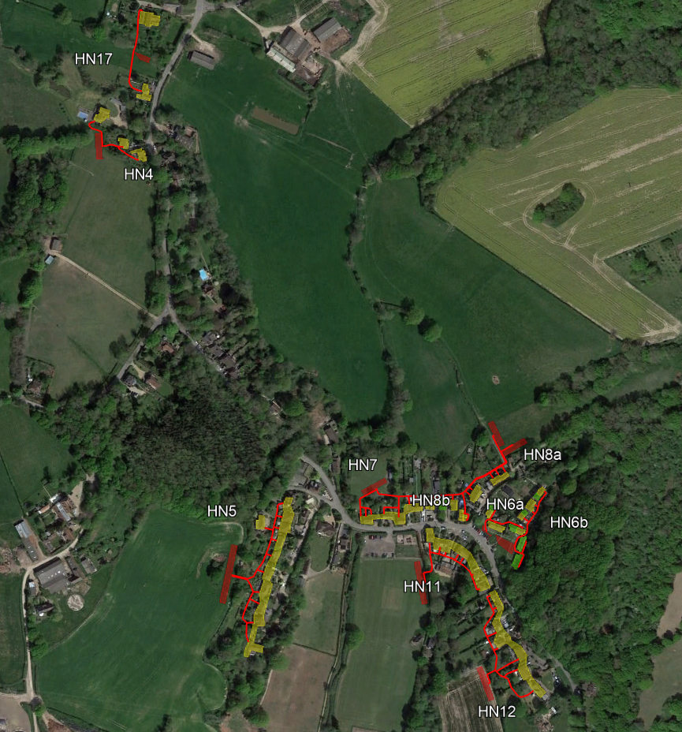
Figure 8: Heat network location – Stonebridge Farm
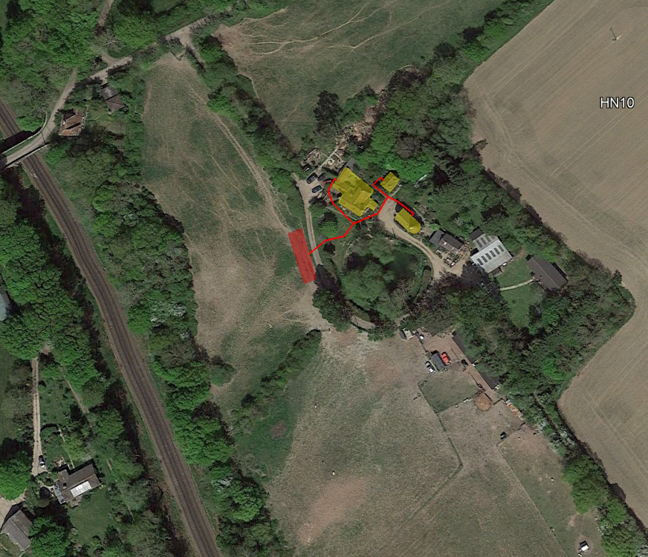
Individual heat networks are assessed for financial viability in the following section.

Air source heat pumps
The following section provides an assessment of air source heat pumps (‘ASHPs) supplying individual properties.
Air source heat pumps - to be completed
The analysis which follows is based on ASHPs replacing existing oil boilers, LPG boilers and electric heating.
- to be completed

Roof mounted solar PV
The following section provides an assessment of individual domestic roof mounted solar PV (‘PV’) systems in the village.
Domestic roof mounted PV systems include PV panels mounted onto the building roof, ideally with minimal shading, at a tilt of around 35° from horizontal, and facing due south in order to generate the maximum amount of electricity. Other tilts, azimuths (between due east and due west) and some amount of shading are possible, however electricity generation will be reduced. Solar panels generate electricity as direct current (‘DC’) and an inverter converts this to alternating current (‘AC’) suitable for use in the property or for export to the local electricity grid, this results in losses in the system. In the UK the vast majority of solar generated electricity is produced during the Spring, Summer and early Autumn, with typically less than 20% generated during the bulk of the heating season period (November to February).
The analysis which follows is based on a village-wide roll out of domestic PV systems.

Solar PV analysis
A high-level PVsyst simulation is provided for a domestic rooftop PV system in Crowhurst, including a range of PV panel tilts including 20°, 30° and 40° from horizontal, and azimuths including east (-90°), southeast (-45°), south (0°), southwest (45°) and west (90°), for 1 kWp capacity system.
The calculated generation profiles do not include any allowance for plant unavailability losses, but include degradation effects during the first year of operation.
A linear degradation rate of 0.4% per year for the modules should be included in the financial model (‘FM’).
There is no allowance for post-inverter energy losses, as this is typically not expected for a domestic rooftop system.
Hourly generation profiles from the PVsyst analysis are used to model the inclusion of a domestic battery energy storage system (‘BESS’) for a typical property, operating in conjunction with a heat pump and electric vehicle (‘EV’) charging.
Based on information gathered from the site visit and Google Earth imagery, the vast majority of domestic properties in the village are considered potentially suitable for rooftop PV, with an amount of available roof space orientated between east and west (-90° to 90°), with some limited amount of shading. The following properties are identified as potentially unsuitable for PV:
- Numbers 1 to 4 Blacksmiths Field (HN6), due to expected high levels of shading from large trees affecting the southeast facing roof space.
- Due to Grade II listed status, and therefore requiring listed building consent:
  - Pyes Farm.
  - Blacklands.
  - Blacklands Farm Cottage.
  - The Brown Cottage.
  - The Furnace.
  - Stonebridge Farmhouse.
It is noted that a small number of properties in the village have PV panels installed.
A summary of the PVsyst analysis of a 1 kWp system is shown in Table 6 below. A typical 1 kWp system will have a PV panel area of around 5.5 m².
Table 6: Summary of PVsyst analysis
Azimuth at tilt from horizontal | PV generation per kWp (kWh/yr)
20° tilt
South 0° | 1,085
Southeast -45° | 1,044
East -90° | 936
Southwest 45° | 1,041
West 90° | 927
30° tilt
South 0° | 1,115
Southeast -45° | 1,061
East -90° | 916
Southwest 45° | 1,056
West 90° | 902
40° tilt
South 0° | 1,122
Southeast -45° | 1,057
East -90° | 888
Southwest 45° | 1,052
West 90° | 870
For larger PV system capacities, the above figures are factored accordingly.
Example hourly profiles for a 2 kWp capacity PV system, as might be typical for a domestic property, with an azimuth due south (0°) and at a tilt of 40°, for March, June, September and December, are shown in Figures 9, 10, 11 and 12 below.
Figure 9: 2 kWp PV system hourly generation profiles - March
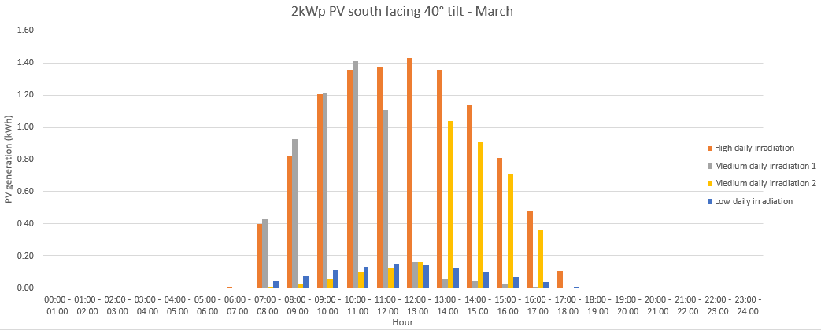
Figure 10: 2 kWp PV system hourly generation profiles - June
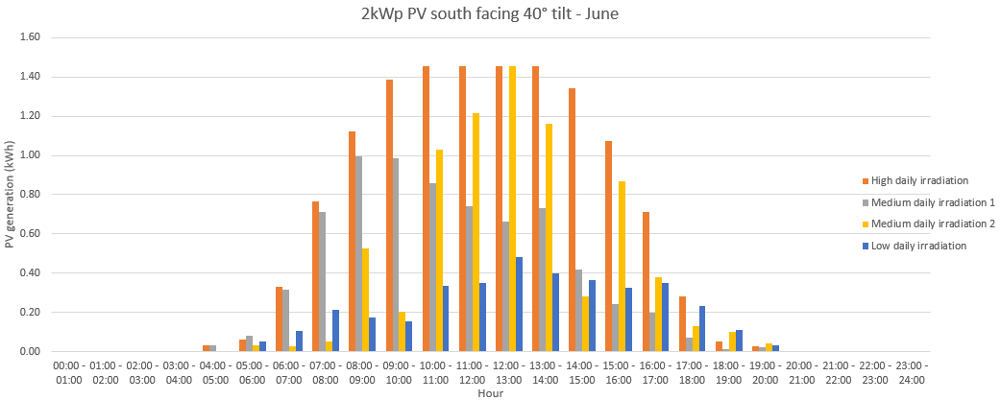
Figure 11: 2 kWp PV system hourly generation profiles - September
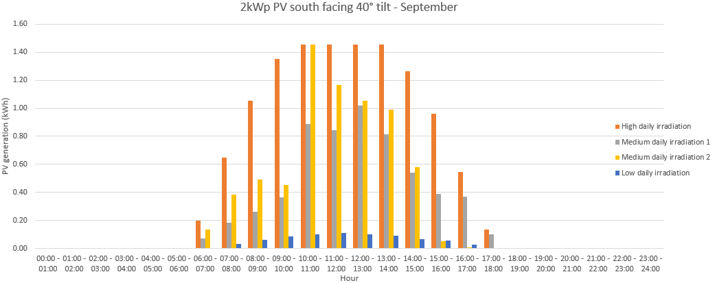
Figure 12: 2 kWp PV system hourly generation profiles - December
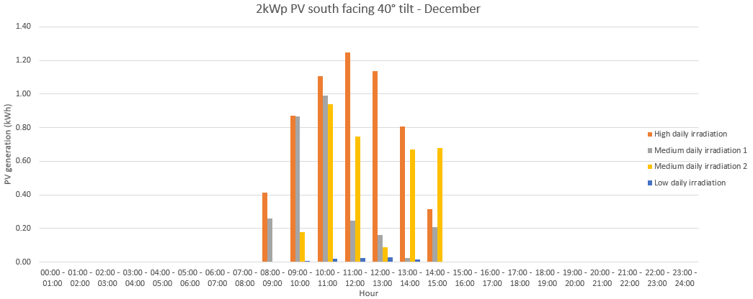
The graphs show the difference in PV generation between the seasons, and the variability in daily generation between highest and lowest irradiances.
An analysis of monthly electricity demand for a typical mid-size domestic property (3 bedrooms, 120m² floor area) and including a GSHP, compared with monthly PV generation for a 2 kWp capacity system is shown in Table 7 below.

Table 7: Domestic monthly electricity demand compared to 2 kWp PV generation
Month | Electricity demand (kWh) | PV generation (kWh) | Percentage of PV generation offsetting electricity demand | PV generation offsetting electricity demand (kWh) | PV export to grid (kWh)
January | 956 | 90 | 90% | 81 | 9
February | 838 | 116 | 85% | 99 | 17
March | 799 | 192 | 82% | 158 | 35
April | 610 | 252 | 79% | 199 | 53
May | 470 | 266 | 76% | 202 | 64
June | 368 | 274 | 73% | 200 | 74
July | 344 | 269 | 70% | 188 | 81
August | 366 | 251 | 75% | 188 | 63
September | 420 | 205 | 80% | 164 | 41
October | 569 | 155 | 85% | 132 | 23
November | 792 | 98 | 90% | 88 | 10
December | 986 | 76 | 95% | 72 | 4
Totals | 7,517 | 2,245 | 79% | 1,772 | 473
The percentage of PV generation offsetting demand figures are estimates based on an assessment of monthly PV generation vs. electricity demand profiles. Example profiles for the months of March, June, September and December are shown in Figures 13, 14, 15, 16 below. It is assumed that from September to March HW is generated at night when lower cost electricity may be available, and from April to August HW is generated during the day to maximise the use of available PV generation.
An example EV charging demand profile is also shown, however this is not considered in the percentage estimates.
Applying the above figures to all properties connected to heat networks, assuming that this may represent the average across all properties, gives the following.
- PV generated offsetting electricity demand 294.1 MWh/yr.
- PV generated and exported to the grid 78.5 MWh/yr.

Figure 13: 2 kWp PV hourly generation vs. electricity demand profiles - March
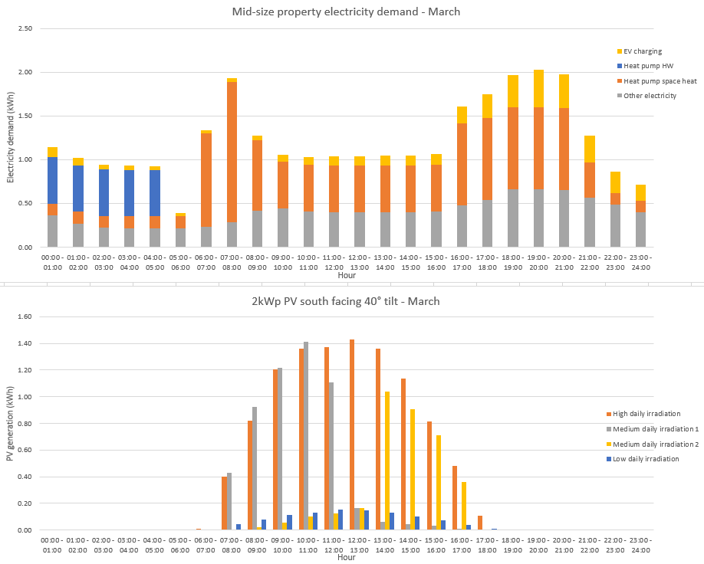
Figure 14: 2 kWp PV hourly generation vs. electricity demand profiles - June
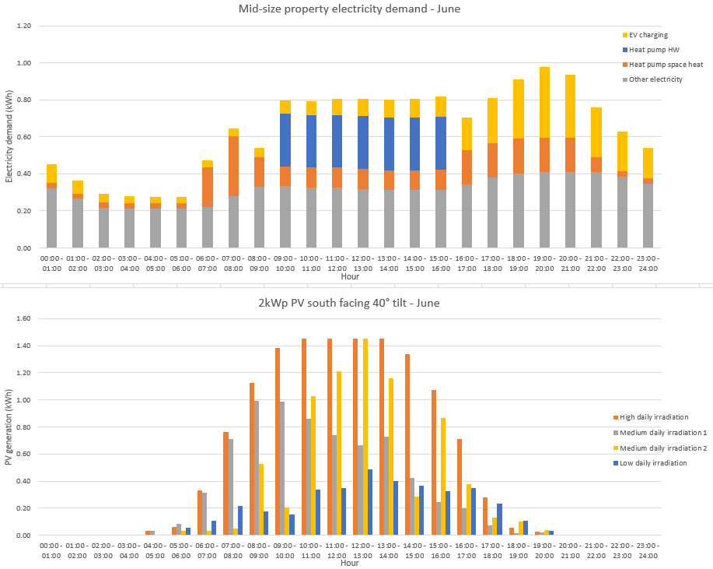
Figure 15: 2 kWp PV hourly generation vs. electricity demand profiles - September
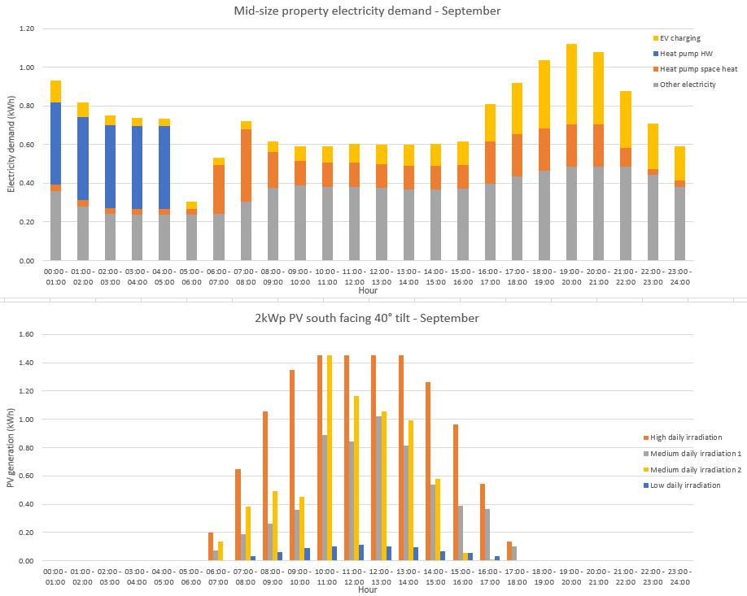
Figure 16: 2 kWp PV hourly generation vs. electricity demand profiles - December
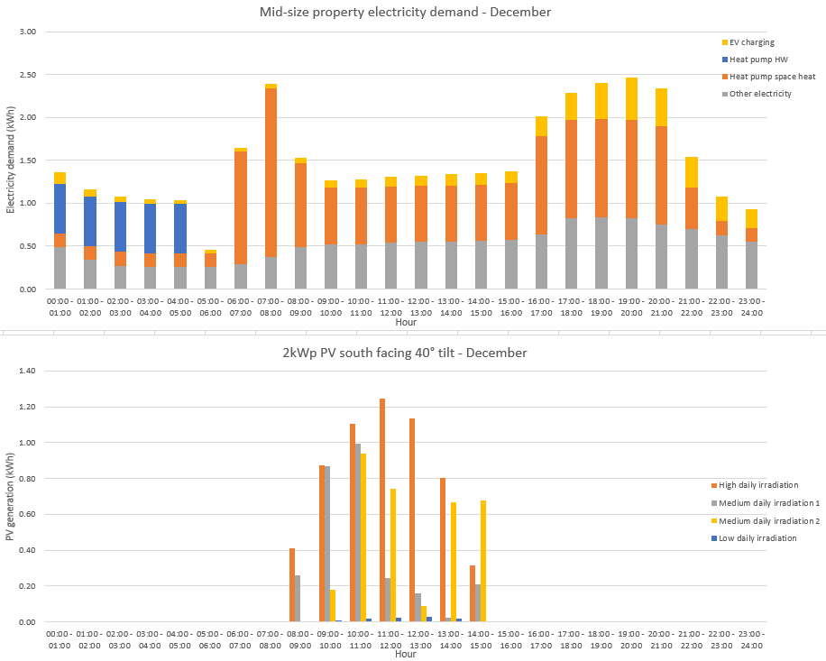

Electric vehicle charging
The following section provides an assessment of domestic EV charging.

EV charging analysis
xxxxxx

Battery storage
The following section provides an assessment of domestic BESS.

Battery storage analysis
xxxxxx

Appendix A –

Appendix B –

RINA Tech UK Ltd.
Huntingdon House
20-25 North Street
Brighton, BN1 1EB, UK
+44 (0)1273 819 429
rina.org

