Crowhurst Parish Council

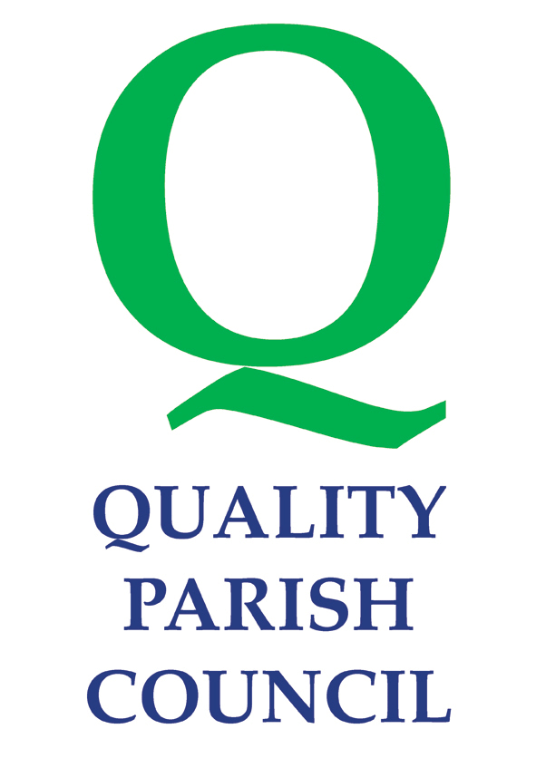

Press and Media Policy

Adopted by Council at a Meeting held on 15 November 2010.

Press and Media Policy

The purpose of this policy is to provide guidance for Councillors and the Clerk on how to deal with some of the practical issues that may arise when dealing with the Press and Media.

Above all, Councillors must observe the Members’ Code of Conduct whenever s/he conducts the business of the Council, conducts the business of the office to which s/he has been elected/appointed or acts as a representative of the Council.

The Clerk

The Clerk as the Proper Officer of the Council, is authorised to receive all communications from the Press and Media and to issue Press Statements on behalf of the Council in consultation with the Chairman. In the absence of the Clerk, media communications will be handled by the Chairman of the Parish Council. All communications made by the Clerk will relate to the stated business and day to day management of the activities or adopted policy of the Council. S/He is not expected or authorised to speculate on matters that have not been considered by the Council. Where such questions are put to the Clerk, s/he should inform the enquirer that they will be notified of the response within 24 hours. The Clerk should then consult with the Chairman or relevant Councillor.

Parish Councillors

Councillors should be aware that case law states that the role of Councillor overrides the rights to act as an individual. Councillors should be careful about expressing individual views to the press or media, whether or not they relate to matters of Council business. Whilst it may be legitimate for a Councillor to make clear that s/he voted against a policy if this took place in an open session, Councillors should not seek to undermine a decision through the Press.

A Councillor must not disclose information that is of a confidential nature. This includes any discussion with the Press on any matter which has been discussed under confidential items on the Council’s or Committee’s agenda or at any other private briefing.

A Councillor should act with integrity at all times when representing or acting on behalf of the Parish Council.

Take particular care if the Press or Media ask for a comment on a controversial subject, and do not be led into stating something that you really did not mean to say. If unsure about any particular policy inform the enquirer that they will be notified of the response within 24 hours.

Never use the prefix ‘Councillor’ when writing to the Press as an individual. This implies you are stating Council policy. However, a copy of any written material sent to the Press and/or Media by a Councillor, as representing the Council, must be forwarded to the Clerk.

A Councillor should not raise matters relating to the conduct or capability of an officer at meetings held in public or before the Press.

Dealing with the Press

When dealing with the Press verbally, Councillors and the Clerk should be aware of the following:
- Be calm
- Be informed and certain of all your facts
- Ensure that when making comments on behalf of the Council that you are aware what Council Policy is and that your comments reflect that policy
- Ensure that your comments and views will not bring the Council, its Councillors or staff, into disrepute and ensure that comments are neither libellous nor slanderous.

Issues to be Aware of

Councillors and the Clerk not used to dealing with the Press may be surprised when they see that statements made in all innocence look very different in print than when they were spoken. It is advantageous to write out a statement or position beforehand.

Meetings of Council and Committees

Copies of agenda, minutes and reports sent to Members for meetings of the Council or its Committees will be available to the Press and Media and placed on the Council’s website.

As provided in the Council’s Standing Orders both the Press and Public may be excluded from a meeting whilst certain confidential matters (as provided for in the relevant legislation) are under discussion.
Note: The Parish Council is governed by the Public Bodies (Admission to Meetings) Act 1960.

Press Releases

All press releases made on behalf of the Council will be prepared by the Clerk following any meetings of the Council or Committees.

The Clerk, in consultation with the Chairman, is also authorised to publish press releases on any urgent matters where there is insufficient time for a Council meeting.

This document has been prepared as a guidance note for Councillors and the Clerk. It represents the Policy of the Council in respect of its relationships with the Press and Media. The Policy has been prepared to ensure consistency in the Council’s dealings with the Press and Media and details who is authorised to speak on behalf of the Council. It has been drafted to ensure that the views and policies of the Council are presented accurately.

In providing information to the Press and Media, Councillors and the Clerk representing the Council will abide by the ‘Code of Recommended Practice on Local Authority Publicity’ published by the Department for Communities and Local Government.

The overriding principle of the Policy is that all elements of the Press and Media will be treated equally.

November 2010

